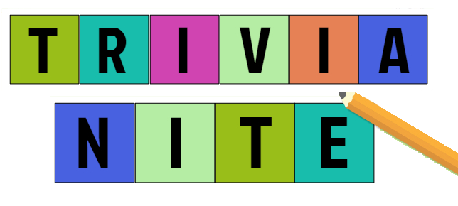
REGISTRATION
FORM

Our Trivia Nite teams of 8-10 people will compete to prove their wit and demonstrate how much useless knowledge they possess!
No worries if you don’t have a team, you can join one that night! All while competing for bragging rights to be the 2023 Trivia Nite Champions.
Saturday, February 11, 2023 - St. Sophia Greek Orthodox Church
Father John A. Limberakis Cultural Center
Doors open at 5pm – Trivia begins at 6pm
$25 per person

To register send your completed registration form in with a check(s) made payable to
St. Sophia Philoptochos by January 20, 2023 and mail to:
St. Sophia Greek Orthodox Church
900 S. Trooper Road, Jeffersonville, PA 19403
Attn: TRIVIA NITE
Feel free to bring snacks or your favorite beverage for YOUR round table.

NAMES (LIST EACH PLAYER SEPARATELY) | AMOUNT | EMAIL ADDRESS (FOR FUTURE EVENT DETAILS)
TEAM NAME:
1. | $25 PER PERSON
2 | $25 PER PERSON
3. | $25 PER PERSON
4. | $25 PER PERSON
5. | $25 PER PERSON
6. | $25 PER PERSON
7. | $25 PER PERSON
8 | $25 PER PERSON
9. | $25 PER PERSON
10. | $25 PER PERSON
TEAM CAPTAIN NAME:
PHONE NUMBER:
PLEASE PUT THE NAME & PHONE NUMBER OF THE TEAM CAPTAIN IN CASE WE HAVE QUESTIONS AND NEED TO CONTACT THEM. IF YOU HAVE ANY QUESTIONS, PLEASE EMAIL ladies@saintsophiachurch.org

